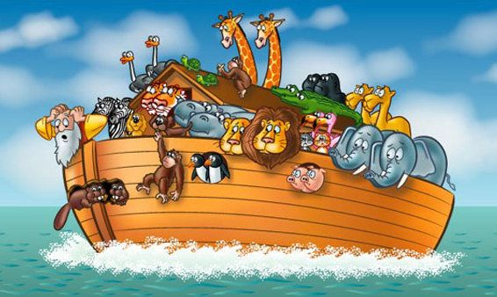

|  |  |  |  |  |  |
| --- | --- | --- | --- | --- | --- |
|  |  |  |  |  |  |
|  |  |  |  |  |  |
|  |  |  |  |  |  |
|  |  |  |  |  |  |
|  |  |  |  |  |  |
|  |  |  |  |  |  |
|  |  |  |  |  |  |
|  |  |  |  |  |  |
|  |  |  |  |  |  |

|  |  |  |  |  |  |
| --- | --- | --- | --- | --- | --- |
|  |  | Afbeeldingsresultaten voor plaatje noach |  |  |  |
|  |  |  |  |  |  |
|  |  |  |  |  |  |
|  |  |  |  |  |  |
|  |  |  |  |  |  |
|  |  |  |  |  |  |
|  |  |  |  |  |  |
|  |  |  |  |  |  |
|  |  |  |  |  |  |